Special Area OSPF Lab

-Tanishk Singh

Purpose

The motive of the lab was to put our research on the special areas of OSPF, i.e. Stub, totally Stubby, and Not-So-Stubby Areas, to real life. The areas differ from one another as they all pass out different types of *Link State Advertisements,* and in some cases the area needs to have a *special* network. We had to implement all the special areas of OSPF in one topology and make the whole work, hence, giving us a significant knowledge of OSPF, and gaining an experience of implementing different kinds of OSPF areas, and verifying their existence on a Protocol Analyzer. The Protocol Analyzer that we used for this lab was Wireshark.

Background Information

* Images and examples are utilized in the following explanation.

Link state routing protocols are one of the two main classes of routing protocols used in networking, the other being distance-vector protocol. When configured correctly, all the routers using the link state routing protocol can create a map or a “picture” of the topology. One example of Link state routing protocol is OSPF (Open Shortest Path First). When OSPF is used to route externally (outside of the area), it is also known as Multi-Area OSPF. There are various kinds of OSPF Areas. The ones covered in the following explanation are, Standard Area, Stub Area, Totally Stubby Area and Not-So-Stubby Area. Another type of OSPF area, the Backbone area (configured by setting the area ID 0.0.0.0), is also used to help understand the types of OSPF areas mentioned above.

Standard Areas work fine and ensure optimal routing because if configured correctly, all the nodes in the topology know about the other nodes. the normal area too, however, has its own setbacks. One of the major problem with standard OSPF Areas is that they increase the router resource utilization. To fix this problem, Cisco invented the different types of OSPF areas: Stub Area, Totally Stubby Area and Not-So-Stubby Area.

Prior to start reading the following explanation, one would want to know the different types of *Link State Advertisements (LSAs)*, something that nodes rely on to communicate information between neighbors in an OSPF process. LSAs are used to share local routing topology to all other local routers in the same OSPF area or outside of an area, depending on the type of OSPF Area being used. OSPF is designed for scalability, so some LSAs are not flooded out on all interfaces, but only on those that belong to the appropriate area. In this way detailed information can be kept localized, while summary information is flooded to the rest of the network. The original IPv4-only OSPFv2 and the newer IPv6-compatible OSPFv3 have broadly similar LSA types. OSPF LSA packets are highlighted with black color to help us identify them among the different kinds of OSPF packets. *Ospf.lsa* is a term to search on Wireshark to get just the LSA packets. Here is a brief review of the most applicable LSA types: -

Type 1 (represents a router), Type 2 (represents the designated router for a multi-access link), Type 3 (a network link summary (internal route)), Type 4 (represents an ASBR), Type 5 (a route external to the OSPF domain), Type 7 (used in stub areas in place of a type 5 LSA).

LSA types 1 and 2 are found in all areas and are never flooded outside of an area. Whether the other types of LSAs are advertised within an area depends on the area type. Below are the names of OSPF areas.

Standard Area

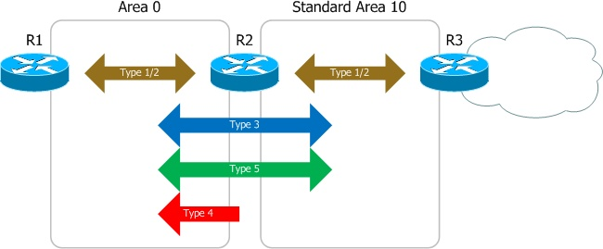

Normal areas work fine and ensure optimal routing, since all routers know about all the other routes.

In the image above, R2 acts as an Area Border Router (ABR) between R3 in a standard Area, Area 10, and the Backbone area, also known as Area 0. Because R3 is redistributing routes from an external domain, it can also be called Autonomous System Boundary Router (ASBR).

As mentioned above and shown in the picture above, LSA type 1 and 2 are only flooded between nodes sharing an area. This applies to all area types, as these LSAs are used to build an area's shortest-path tree, and consequently only relevant to a single area. Type 3 LSAs and Type 5 LSAs, describe internal and external IP routes, respectively, and are flooded throughout Area 0 (Backbone Area) and the standard area (Area 10 in the above scenario). Only an ASBR holds the potential to generate type 5 LSAs, which in the above case is R3. Type 3 LSAs, whereas can be generated by any node performing OSPF.

To verify or analyze the performance of a network, network engineers use certain types of software, termed as *Protocol Analyzers*. Wireshark has been used in the entire explanation, as an example of a protocol analyzer. If, in this situation, one plugs adds an end host to either R1 or R2, and analyzes packets arriving from Standard Area 10, he/she would be able to verify the working of the area as he/she can see (E) External Routing: Capable and (N) NSSA: Not supported, under the *OSPF Hello Packet* section. This signifies that the following OSPF Area can perform routing externally, and it is not NSSA (A type of OSPF area that is covered below).

In the image above, however, another LSA type, LSA type 4, is flooded from the ABR to the Backbone area. To perform it, the ABR needs to be connected to an area that contains the ASBR. This is to ensure hundred per cent connectivity to the ASBR.

Stub Areas

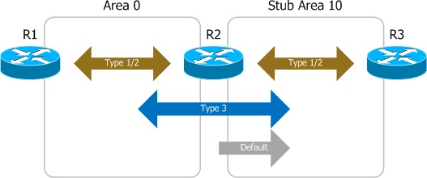

As depicted in the image above, the ABR (R2, in the above scenario), instead of using type 5 LSAs for sending external routes, injects type 3 LSAs into the backbone area, and into the stub area, with a default route. This ensures connectivity of the stub area into other areas, without the node in it being able to maintain all the external routes. Because external routes are not received by Stub areas, ABRs do not forward type 4 LSAs into the stub area.

One can verify the existence of a Stub area on Wireshark by being able to see, (E) External Routing: Not Capable and Area ID: 0.0.0.10. This shows that External routing is not supported by the OSPF area 10, which, in this scenario is the Stub area.

For an area to become a stub, all routers belonging to it must be configured to operate as such. Stub routers and non-stub routers will not form adjacencies.

Router(config-router)# area 10 stub

Totally Stubby Areas

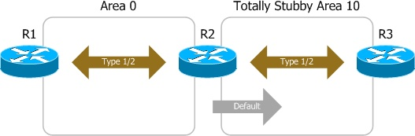

One can compare the stub and totally stubby areas. Both the kinds of areas are similar in that both do not use type 4 or 5 LSAs. However, unlike Stub area OSPF, Totally Stubby do not also use type 3 LSAs, and is also a Cisco Proprietary. The whole routing process relies on a single default route, injected by the ABR. A stub area is extended to a totally stubby area by configuring all its ABRs with the no-summary parameter: -

Router(config-router)# area 10 stub no-summary

When connecting an end host to one of the routers in the topology and attempting to understand the mechanism of the Totally Stubby Area, one can view 1. (E) External Routing: Not Capable, 2. Area ID: 0.0.0.10, under options of an *OSPF Hello Packet* on Wireshark. Through Wireshark, Networkers can derive that Totally Stubby does not undergo external routing with OSPF because none of the nodes in the topology hold information about any other node, and the second statement shows the area that the packet came, which in this case happens to be the Totally Stubby Area. The person analyzing on the Wireshark, can differentiate between a Totally Stubby Area and the Stub Area by their Area IDs, on the protocol analyzer.

Totally Stubby and Stub Area can be convenient in reducing resource utilization on the nodes. However, neither of them can have an ASBR as both cannot permit the use of type 4 and 5 LSAs. To solve this problem, Cisco invented another term known as *Not-so-Stubby Areas.*

Not-so-Stubby Areas

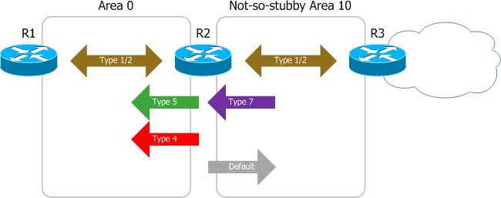

An NSSA utilizes type 7 LSAs, which can essentially be called type 5 LSAs in disguise. This allows an ASBR to advertise externally to an ABR, which convert those type 7 LSAs into type 5 LSAs before flooding them to the rest of the OSPF domain.

to designate a normal (stub) NSSA, all routers in the area must be so configured: -

Router(config-router)# area 10 nssa

Type 3 LSAs will pass into and out of the area. Unlike a normal stub area, the ABR will not inject a default route into an NSSA unless explicitly configured to do so. As traffic cannot be routed to external destinations without a default route, you'll probably want to include one by appending *default-information originate*.

Router(config-router)# area 10 nssa default-information-originate

To expand an NSSA to function as a totally stubby area, eliminating type 3 LSAs, all its ABRs must be configured with the *no-summary* parameter: -

Router(config-router)# area 10 nssa no-summary

The ABR of a totally stubby NSSA (or not-so-totally-stubby area, if you prefer) injects a default route without any further configuration.

There is a specific term on Wireshark that differentiates an NSSA from all the other types of OSPF Areas. Under the *Options* menu of the *OSPF Hello Packet*, if it reads (N) NSSA: Supported, it gets verified that the specific OSPF Hello Packet has been obtained from the NSSA (Not-So-Stubby Area). Since NSSA can do external routing, one can also be able to see (E) External Routing: Capable.

Lab Summary

We made a topology on a virtual application (or software), *Cisco Packet Trace*. The end topology consisted of two layer 3 switches, five routers and a PC. Afterwards, we assigned IP addresses of the nodes’ interfaces and the PC. Then, we moved on to one of the most important task required to complete the lab. We assigned the specific nodes with their respective OSPF areas. Since we require an ASBR in the execution of the NSSA, we also needed to decide upon a protocol, other than OSPF, connected to the ASBR, and so we chose the protocol called, RIP. We applied all the commands on Packet Tracer, and copied them to the real-life routers and switches used in the topology. Some fresh commands were added or changed on the nodes either because Cisco Packet Tracer did not support few of the commands needed for a working topology, or we did it because of the situation.

Commands

|  |  |
| --- | --- |
| monitor session session_number source *{ interface interface-id | vlan vlan-id } [ , | - ] [ both | rx | tx ]* | Specify the SPAN session and the source port (monitored port).  For session number, the range is 1 to 66.  For interface-id, specify the source port or source VLAN to monitor.  For source interface-id, specify the source port to monitor. Valid interfaces include physical interfaces and port-channel logical interfaces (port-channel port-channel-number). Valid port-channel numbers are 1 to 48.  For vlan-id, specify the source VLAN to monitor. The range is 1 to 4094 (excluding the RSPAN VLAN).  Note A single session can include multiple sources (ports or VLANs), defined in a series of commands, but you cannot combine source ports and source VLANs in one session.  (Optional) [ , | - ] Specify a series or range of interfaces. Enter a space before and after the comma; enter a space before and after the hyphen.  (Optional) Specify the direction of traffic to monitor. If you do not specify a traffic direction, the SPAN monitors both sent and received traffic.  both —Monitor both received and sent traffic. This is the default.  rx —Monitor received traffic.  tx —Monitor sent traffic.  Note You can use the monitor session session number source command multiple times to configure multiple source ports. |
| monitor session session_number destination *{ interface interface-id* *[, | -]* *[ encapsulation replicate]}* | Specify the SPAN session and the destination port (monitoring port).  For session_number, specify the session number entered in step 3.  Note For local SPAN, you must use the same session number for the source and destination interfaces.  For interface-id, specify the destination port. The destination interface must be a physical port; it cannot be an EtherChannel, and it cannot be a VLAN.  (Optional) [ , | - ] Specify a series or range of interfaces. Enter a space before and after the comma; enter a space before and after the hyphen.  (Optional) Enter encapsulation replicate to specify that the destination interface replicates the source interface encapsulation method. If not selected, the default is to send packets in native form (untagged).  Note You can use monitor session session_number destination command multiple times to configure multiple destination ports |
| Area *{area-id}* stub | To make an OSPF Area, a stub area. |
| Area {area-id} stub no-summary | To make an OSPF Area, a totally Stubby Area. |
| Area {area-id} nssa | To make an OSPF Area, an NSSA |
| Area {area-id} nssa default-information-originate | To advertise Type 7 LSA in the area. |

Topology and IP Addressing Scheme

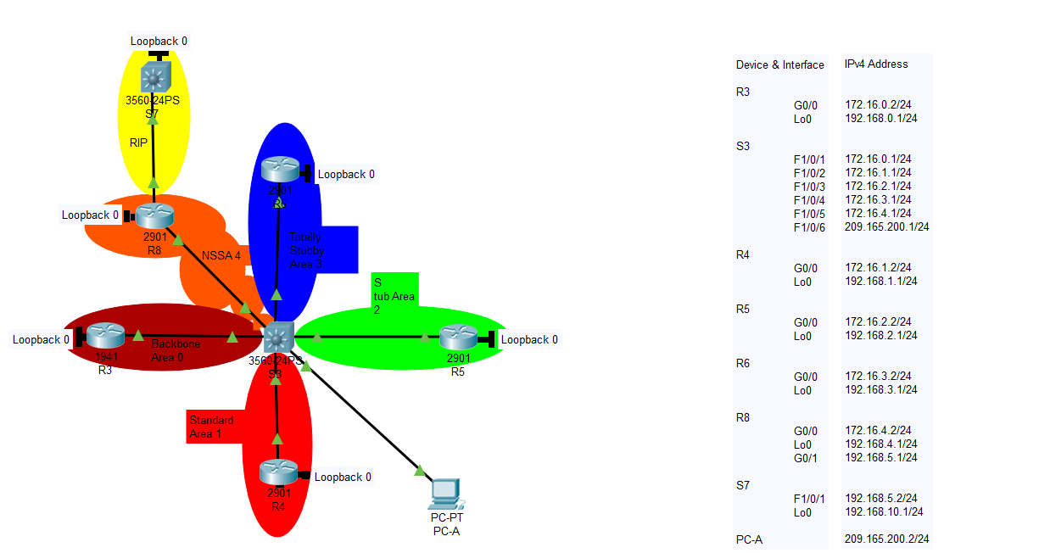

Configurations and Result

R3 Configuration

hostname R3

boot-start-marker

boot-end-marker

no aaa new-model

memory-size iomem 25

ip cef

no ipv6 cef

multilink bundle-name authenticated

voice-card 0

license udi pid CISCO2901/K9 sn FTX180180LJ

license accept end user agreement

license boot module c2900 technology-package securityk9

license boot module c2900 technology-package uck9

vtp domain cisco

vtp mode transparent

redundancy

interface Loopback0

ip address 192.168.0.1 255.255.255.0

interface Embedded-Service-Engine0/0

no ip address

shutdown

interface GigabitEthernet0/0

ip address 172.16.0.2 255.255.255.0

duplex auto

speed auto

interface GigabitEthernet0/1

ip address 209.165.200.1 255.255.255.0

duplex auto

speed auto

interface Serial0/0/0

no ip address

shutdown

clock rate 2000000

interface Serial0/0/1

no ip address

shutdown

clock rate 2000000

router ospf 1

router-id 1.1.1.1

passive-interface Loopback0

network 172.16.0.0 0.0.0.255 area 0

network 192.168.0.0 0.0.0.255 area 0

network 209.165.200.0 0.0.0.255 area 0

default-information originate

ip forward-protocol nd

no ip http server

no ip http secure-server

ip flow-export version 9

ip route 0.0.0.0 0.0.0.0 GigabitEthernet0/0

control-plane

mgcp profile default

gatekeeper

shutdown

line con 0

line aux 0

line 2

no activation-character

no exec

transport preferred none

transport output lat pad telnet rlogin lapb-ta mop udptn v120 ssh

stopbits 1

line vty 0 4

login

transport input all

scheduler allocate 20000 1000

end

R3 IP Route

Codes: L - local, C - connected, S - static, R - RIP, M - mobile, B - BGP

D - EIGRP, EX - EIGRP external, O - OSPF, IA - OSPF inter area

N1 - OSPF NSSA external type 1, N2 - OSPF NSSA external type 2

E1 - OSPF external type 1, E2 - OSPF external type 2

i - IS-IS, su - IS-IS summary, L1 - IS-IS level-1, L2 - IS-IS level-2

ia - IS-IS inter area, * - candidate default, U - per-user static route

o - ODR, P - periodic downloaded static route, H - NHRP, l - LISP

+ - replicated route, % - next hop override

Gateway of last resort is 0.0.0.0 to network 0.0.0.0

S* 0.0.0.0/0 is directly connected, GigabitEthernet0/0

172.16.0.0/16 is variably subnetted, 6 subnets, 2 masks

C 172.16.0.0/24 is directly connected, GigabitEthernet0/0

L 172.16.0.2/32 is directly connected, GigabitEthernet0/0

O IA 172.16.1.0/24 [110/2] via 172.16.0.1, 00:08:42, GigabitEthernet0/0

O IA 172.16.2.0/24 [110/2] via 172.16.0.1, 00:08:42, GigabitEthernet0/0

O IA 172.16.3.0/24 [110/2] via 172.16.0.1, 00:08:42, GigabitEthernet0/0

O IA 172.16.4.0/24 [110/2] via 172.16.0.1, 00:08:42, GigabitEthernet0/0

192.168.0.0/24 is variably subnetted, 2 subnets, 2 masks

C 192.168.0.0/24 is directly connected, Loopback0

L 192.168.0.1/32 is directly connected, Loopback0

192.168.1.0/32 is subnetted, 1 subnets

O IA 192.168.1.1 [110/3] via 172.16.0.1, 00:08:42, GigabitEthernet0/0

192.168.2.0/32 is subnetted, 1 subnets

O IA 192.168.2.1 [110/3] via 172.16.0.1, 00:08:42, GigabitEthernet0/0

192.168.3.0/32 is subnetted, 1 subnets

O IA 192.168.3.1 [110/3] via 172.16.0.1, 00:08:42, GigabitEthernet0/0

192.168.4.0/32 is subnetted, 1 subnets

O IA 192.168.4.1 [110/3] via 172.16.0.1, 00:08:42, GigabitEthernet0/0

O E2 192.168.5.0/24 [110/20] via 172.16.0.1, 00:07:58, GigabitEthernet0/0

O E2 192.168.10.0/24 [110/20] via 172.16.0.1, 00:07:36, GigabitEthernet0/0

O IA 209.165.200.0/24 [110/2] via 172.16.0.1, 00:08:42, GigabitEthernet0/0

R4 Configuration

hostname R4

boot-start-marker

boot-end-marker

no aaa new-model

memory-size iomem 25

ip cef

no ipv6 cef

multilink bundle-name authenticated

voice-card 0

license udi pid CISCO2901/K9 sn FTX180180LT

license accept end user agreement

license boot module c2900 technology-package securityk9

license boot module c2900 technology-package uck9

vtp domain cisco

vtp mode transparent

redundancy

interface Loopback0

ip address 192.168.1.1 255.255.255.0

interface Embedded-Service-Engine0/0

no ip address

shutdown

interface GigabitEthernet0/0

ip address 172.16.1.2 255.255.255.0

duplex auto

speed auto

interface GigabitEthernet0/1

ip address 209.165.201.1 255.255.255.0

duplex auto

speed auto

interface Serial0/0/0

no ip address

shutdown

clock rate 2000000

interface Serial0/0/1

no ip address

shutdown

clock rate 2000000

interface GigabitEthernet0/1/0

no ip address

shutdown

duplex auto

speed auto

router ospf 1

router-id 3.3.3.3

passive-interface Loopback0

network 172.16.1.0 0.0.0.255 area 1

network 192.168.1.0 0.0.0.255 area 1

network 209.165.201.0 0.0.0.255 area 1

default-information originate

ip forward-protocol nd

no ip http server

no ip http secure-server

ip flow-export version 9

ip route 0.0.0.0 0.0.0.0 GigabitEthernet0/0

control-plane

mgcp profile default

gatekeeper

shutdown

line con 0

line aux 0

line 2

no activation-character

no exec

transport preferred none

transport output lat pad telnet rlogin lapb-ta mop udptn v120 ssh

stopbits 1

line vty 0 4

login

transport input all

scheduler allocate 20000 1000

end

R4 IP Routes

Codes: L - local, C - connected, S - static, R - RIP, M - mobile, B - BGP

D - EIGRP, EX - EIGRP external, O - OSPF, IA - OSPF inter area

N1 - OSPF NSSA external type 1, N2 - OSPF NSSA external type 2

E1 - OSPF external type 1, E2 - OSPF external type 2

i - IS-IS, su - IS-IS summary, L1 - IS-IS level-1, L2 - IS-IS level-2

ia - IS-IS inter area, * - candidate default, U - per-user static route

o - ODR, P - periodic downloaded static route, H - NHRP, l - LISP

+ - replicated route, % - next hop override

Gateway of last resort is 0.0.0.0 to network 0.0.0.0

S* 0.0.0.0/0 is directly connected, GigabitEthernet0/0

172.16.0.0/16 is variably subnetted, 6 subnets, 2 masks

O IA 172.16.0.0/24 [110/2] via 172.16.1.1, 00:08:02, GigabitEthernet0/0

C 172.16.1.0/24 is directly connected, GigabitEthernet0/0

L 172.16.1.2/32 is directly connected, GigabitEthernet0/0

O IA 172.16.2.0/24 [110/2] via 172.16.1.1, 00:08:02, GigabitEthernet0/0

O IA 172.16.3.0/24 [110/2] via 172.16.1.1, 00:08:02, GigabitEthernet0/0

O IA 172.16.4.0/24 [110/2] via 172.16.1.1, 00:08:02, GigabitEthernet0/0

192.168.0.0/32 is subnetted, 1 subnets

O IA 192.168.0.1 [110/3] via 172.16.1.1, 00:08:02, GigabitEthernet0/0

192.168.1.0/24 is variably subnetted, 2 subnets, 2 masks

C 192.168.1.0/24 is directly connected, Loopback0

L 192.168.1.1/32 is directly connected, Loopback0

192.168.2.0/32 is subnetted, 1 subnets

O IA 192.168.2.1 [110/3] via 172.16.1.1, 00:08:02, GigabitEthernet0/0

192.168.3.0/32 is subnetted, 1 subnets

O IA 192.168.3.1 [110/3] via 172.16.1.1, 00:08:02, GigabitEthernet0/0

192.168.4.0/32 is subnetted, 1 subnets

O IA 192.168.4.1 [110/3] via 172.16.1.1, 00:08:02, GigabitEthernet0/0

O E2 192.168.5.0/24 [110/20] via 172.16.1.1, 00:07:15, GigabitEthernet0/0

O E2 192.168.10.0/24 [110/20] via 172.16.1.1, 00:06:53, GigabitEthernet0/0

O IA 209.165.200.0/24 [110/2] via 172.16.1.1, 00:08:02, GigabitEthernet0/0

R5 Configuration

hostname R5

boot-start-marker

boot-end-marker

no aaa new-model

memory-size iomem 10

ip cef

no ipv6 cef

multilink bundle-name authenticated

voice-card 0

license udi pid CISCO2901/K9 sn FTX1528859Z

license accept end user agreement

license boot module c2900 technology-package securityk9

license boot module c2900 technology-package uck9

vtp domain cisco

vtp mode transparent

redundancy

interface Loopback0

ip address 192.168.2.1 255.255.255.0

interface Embedded-Service-Engine0/0

no ip address

shutdown

interface GigabitEthernet0/0

ip address 172.16.2.2 255.255.255.0

duplex auto

speed auto

bridge-group 1

interface GigabitEthernet0/1

ip address 209.165.201.1 255.255.255.0

duplex auto

speed auto

bridge-group 1

interface Serial0/0/0

no ip address

shutdown

clock rate 2000000

interface Serial0/0/1

no ip address

shutdown

clock rate 2000000

interface GigabitEthernet0/1/0

no ip address

shutdown

duplex auto

speed auto

router ospf 1

router-id 4.4.4.4

area 2 stub

passive-interface Loopback0

network 172.16.2.0 0.0.0.255 area 2

network 192.168.2.0 0.0.0.255 area 2

network 209.165.201.0 0.0.0.255 area 2

default-information originate

ip forward-protocol nd

no ip http server

no ip http secure-server

ip flow-export version 9

ip route 0.0.0.0 0.0.0.0 GigabitEthernet0/0

control-plane

mgcp profile default

gatekeeper

shutdown

line con 0

line aux 0

line 2

no activation-character

no exec

transport preferred none

transport output lat pad telnet rlogin lapb-ta mop udptn v120 ssh

stopbits 1

line vty 0 4

login

transport input all

scheduler allocate 20000 1000

end

R5 IP Routes

Codes: L - local, C - connected, S - static, R - RIP, M - mobile, B - BGP

D - EIGRP, EX - EIGRP external, O - OSPF, IA - OSPF inter area

N1 - OSPF NSSA external type 1, N2 - OSPF NSSA external type 2

E1 - OSPF external type 1, E2 - OSPF external type 2

i - IS-IS, su - IS-IS summary, L1 - IS-IS level-1, L2 - IS-IS level-2

ia - IS-IS inter area, * - candidate default, U - per-user static route

o - ODR, P - periodic downloaded static route, H - NHRP, l - LISP

+ - replicated route, % - next hop override

Gateway of last resort is 0.0.0.0 to network 0.0.0.0

S* 0.0.0.0/0 is directly connected, GigabitEthernet0/0

172.16.0.0/16 is variably subnetted, 6 subnets, 2 masks

O IA 172.16.0.0/24 [110/2] via 172.16.2.1, 00:07:28, GigabitEthernet0/0

O IA 172.16.1.0/24 [110/2] via 172.16.2.1, 00:07:28, GigabitEthernet0/0

C 172.16.2.0/24 is directly connected, GigabitEthernet0/0

L 172.16.2.2/32 is directly connected, GigabitEthernet0/0

O IA 172.16.3.0/24 [110/2] via 172.16.2.1, 00:07:28, GigabitEthernet0/0

O IA 172.16.4.0/24 [110/2] via 172.16.2.1, 00:07:28, GigabitEthernet0/0

192.168.0.0/32 is subnetted, 1 subnets

O IA 192.168.0.1 [110/3] via 172.16.2.1, 00:07:28, GigabitEthernet0/0

192.168.1.0/32 is subnetted, 1 subnets

O IA 192.168.1.1 [110/3] via 172.16.2.1, 00:07:28, GigabitEthernet0/0

192.168.2.0/24 is variably subnetted, 2 subnets, 2 masks

C 192.168.2.0/24 is directly connected, Loopback0

L 192.168.2.1/32 is directly connected, Loopback0

192.168.3.0/32 is subnetted, 1 subnets

O IA 192.168.3.1 [110/3] via 172.16.2.1, 00:07:28, GigabitEthernet0/0

192.168.4.0/32 is subnetted, 1 subnets

O IA 192.168.4.1 [110/3] via 172.16.2.1, 00:07:28, GigabitEthernet0/0

O IA 209.165.200.0/24 [110/2] via 172.16.2.1, 00:07:28, GigabitEthernet0/0

R6 Configuration

hostname R6

boot-start-marker

boot-end-marker

no aaa new-model

memory-size iomem 10

ip cef

no ipv6 cef

multilink bundle-name authenticated

voice-card 0

license udi pid CISCO2901/K9 sn FTX152885A3

license accept end user agreement

license boot module c2900 technology-package securityk9

license boot module c2900 technology-package uck9

vtp domain cisco

vtp mode transparent

redundancy

interface Loopback0

ip address 192.168.3.1 255.255.255.0

interface Embedded-Service-Engine0/0

no ip address

shutdown

interface GigabitEthernet0/0

ip address 172.16.3.2 255.255.255.0

duplex auto

speed auto

interface GigabitEthernet0/1

no ip address

duplex auto

speed auto

interface Serial0/0/0

no ip address

shutdown

clock rate 2000000

interface Serial0/0/1

no ip address

shutdown

clock rate 2000000

interface GigabitEthernet0/1/0

no ip address

shutdown

duplex auto

speed auto

router ospf 1

router-id 5.5.5.5

area 3 stub no-summary

passive-interface Loopback0

network 172.16.3.0 0.0.0.255 area 3

network 192.168.3.0 0.0.0.255 area 3

default-information originate

ip forward-protocol nd

no ip http server

no ip http secure-server

ip flow-export version 9

ip route 0.0.0.0 0.0.0.0 GigabitEthernet0/0

control-plane

mgcp profile default

gatekeeper

shutdown

line con 0

line aux 0

line 2

no activation-character

no exec

transport preferred none

transport output lat pad telnet rlogin lapb-ta mop udptn v120 ssh

stopbits 1

line vty 0 4

login

transport input all

scheduler allocate 20000 1000

end

R6 IP Routes

Codes: L - local, C - connected, S - static, R - RIP, M - mobile, B - BGP

D - EIGRP, EX - EIGRP external, O - OSPF, IA - OSPF inter area

N1 - OSPF NSSA external type 1, N2 - OSPF NSSA external type 2

E1 - OSPF external type 1, E2 - OSPF external type 2

i - IS-IS, su - IS-IS summary, L1 - IS-IS level-1, L2 - IS-IS level-2

ia - IS-IS inter area, * - candidate default, U - per-user static route

o - ODR, P - periodic downloaded static route, H - NHRP, l - LISP

+ - replicated route, % - next hop override

Gateway of last resort is 0.0.0.0 to network 0.0.0.0

S* 0.0.0.0/0 is directly connected, GigabitEthernet0/0

172.16.0.0/16 is variably subnetted, 2 subnets, 2 masks

C 172.16.3.0/24 is directly connected, GigabitEthernet0/0

L 172.16.3.2/32 is directly connected, GigabitEthernet0/0

192.168.3.0/24 is variably subnetted, 2 subnets, 2 masks

C 192.168.3.0/24 is directly connected, Loopback0

L 192.168.3.1/32 is directly connected, Loopback0

R8 Configuration

hostname R8

boot-start-marker

boot-end-marker

no aaa new-model

memory-size iomem 10

no ipv6 cef

ip source-route

ip cef

multilink bundle-name authenticated

license udi pid CISCO2901/K9 sn FTX1541008N

vtp domain cisco

vtp mode transparent

redundancy

interface Loopback0

ip address 192.168.4.1 255.255.255.0

interface GigabitEthernet0/0

ip address 172.16.4.2 255.255.255.0

duplex auto

speed auto

interface GigabitEthernet0/1

ip address 192.168.5.1 255.255.255.0

duplex auto

speed auto

router ospf 1

log-adjacency-changes

area 4 nssa default-information-originate

redistribute static

redistribute rip subnets

redistribute eigrp 1

passive-interface Loopback0

network 172.16.4.0 0.0.0.255 area 4

network 192.168.4.0 0.0.0.255 area 4

default-information originate

router rip

version 2

redistribute ospf 1

passive-interface Loopback0

network 192.168.5.0

network 172.16.4.0

default-information originate

no auto-summary

ip forward-protocol nd

no ip http server

no ip http secure-server

ip flow-export version 9

ip route 0.0.0.0 0.0.0.0 GigabitEthernet0/0

control-plane

line con 0

line aux 0

line vty 0 4

login

scheduler allocate 20000 1000

end

R8 IP Routes

Codes: L - local, C - connected, S - static, R - RIP, M - mobile, B - BGP

D - EIGRP, EX - EIGRP external, O - OSPF, IA - OSPF inter area

N1 - OSPF NSSA external type 1, N2 - OSPF NSSA external type 2

E1 - OSPF external type 1, E2 - OSPF external type 2

i - IS-IS, su - IS-IS summary, L1 - IS-IS level-1, L2 - IS-IS level-2

ia - IS-IS inter area, * - candidate default, U - per-user static route

o - ODR, P - periodic downloaded static route, + - replicated route

Gateway of last resort is 0.0.0.0 to network 0.0.0.0

S* 0.0.0.0/0 is directly connected, GigabitEthernet0/0

172.16.0.0/16 is variably subnetted, 2 subnets, 2 masks

C 172.16.4.0/24 is directly connected, GigabitEthernet0/0

L 172.16.4.2/32 is directly connected, GigabitEthernet0/0

192.168.4.0/24 is variably subnetted, 2 subnets, 2 masks

C 192.168.4.0/24 is directly connected, Loopback0

L 192.168.4.1/32 is directly connected, Loopback0

192.168.5.0/24 is variably subnetted, 2 subnets, 2 masks

C 192.168.5.0/24 is directly connected, GigabitEthernet0/1

L 192.168.5.1/32 is directly connected, GigabitEthernet0/1

R 192.168.10.0/24 [120/1] via 192.168.5.2, 00:00:29, GigabitEthernet0/1

O 209.165.200.0/24 [110/2] via 172.16.4.1, 00:05:11, GigabitEthernet0/0

S3 Configuration

hostname S3

boot-start-marker

boot-end-marker

no aaa new-model

system mtu routing 1500

ip routing

vtp mode transparent

spanning-tree mode pvst

spanning-tree extend system-id

vlan internal allocation policy ascending

vlan 2

name Area-1

vlan 3

name Area-2

vlan 4

name Area-0

vlan 5

name AREA-0

vlan 10

name Left

vlan 100

name right

vlan 118

name DNET1_VLAN_CE_TO_CUST_CD

vlan 119

name DNET2_VLAN_CE_TO_CUST_CD

vlan 130

name GPNET_VLAN_CUSTOMER_CD

vlan 131

name GPNET2_VLAN_CUSTOMER_CD

vlan 135

name CNET_VLAN_CUSTOMER_CD

vlan 150

name CFWOS_VLAN_CUSTOMER_CD

vlan 190

name SSN1_VLAN_TO_CUSTOMER_CD

vlan 191

name SSN2_VLAN_TO_CUSTOMER_CD

vlan 200

name left

vlan 400

name BRIX_TEST_VLAN

vlan 996

name TRUNK_NATIVE_VLAN

vlan 997

name TRUNK_NATIVE_VLAN_TO_CE

vlan 999

name SPARE_PORTS

interface FastEthernet1/0/1

no switchport

ip address 172.16.0.1 255.255.255.0

interface FastEthernet1/0/2

no switchport

ip address 172.16.1.1 255.255.255.0

interface FastEthernet1/0/3

no switchport

ip address 172.16.2.1 255.255.255.0

interface FastEthernet1/0/4

no switchport

ip address 172.16.3.1 255.255.255.0

interface FastEthernet1/0/5

no switchport

ip address 172.16.4.1 255.255.255.0

interface FastEthernet1/0/6

no switchport

ip address 209.165.200.1 255.255.255.0

interface FastEthernet1/0/7

interface FastEthernet1/0/8

interface FastEthernet1/0/9

interface FastEthernet1/0/10

interface FastEthernet1/0/11

interface FastEthernet1/0/12

interface FastEthernet1/0/13

interface FastEthernet1/0/14

interface FastEthernet1/0/15

interface FastEthernet1/0/16

interface FastEthernet1/0/17

interface FastEthernet1/0/18

interface FastEthernet1/0/19

interface FastEthernet1/0/20

interface FastEthernet1/0/21

interface FastEthernet1/0/22

interface FastEthernet1/0/23

interface FastEthernet1/0/24

interface GigabitEthernet1/0/1

interface GigabitEthernet1/0/2

interface GigabitEthernet1/1/1

interface GigabitEthernet1/1/2

interface Vlan1

no ip address

shutdown

interface Vlan2

no ip address

interface Vlan3

no ip address

interface Vlan4

no ip address

router ospf 1

router-id 2.2.2.2

area 2 stub

area 3 stub no-summary

area 4 nssa no-summary

network 172.16.0.0 0.0.0.255 area 0

network 172.16.1.0 0.0.0.255 area 1

network 172.16.2.0 0.0.0.255 area 2

network 172.16.3.0 0.0.0.255 area 3

network 172.16.4.0 0.0.0.255 area 4

network 209.165.200.0 0.0.0.255 area 4

default-information originate

ip http server

ip http secure-server

ip flow-export version 9

ip route 0.0.0.0 0.0.0.0 192.168.3.2

ip route 172.16.1.0 255.255.255.0 FastEthernet1/0/2

ip route 192.168.1.0 255.255.255.0 FastEthernet1/0/2

ip route 192.168.2.0 255.255.255.0 FastEthernet1/0/3

ip route 192.168.3.0 255.255.255.0 FastEthernet1/0/4

ip route 192.168.4.0 255.255.255.0 FastEthernet1/0/5

logging esm config

line con 0

line vty 0 4

login

line vty 5 15

login

monitor session 2 source interface Fa1/0/3

monitor session 2 destination interface Fa1/0/7

monitor session 3 source interface Fa1/0/4

monitor session 3 destination interface Fa1/0/8

end

S3 IP Routes

Codes: L - local, C - connected, S - static, R - RIP, M - mobile, B - BGP

D - EIGRP, EX - EIGRP external, O - OSPF, IA - OSPF inter area

N1 - OSPF NSSA external type 1, N2 - OSPF NSSA external type 2

E1 - OSPF external type 1, E2 - OSPF external type 2

i - IS-IS, su - IS-IS summary, L1 - IS-IS level-1, L2 - IS-IS level-2

ia - IS-IS inter area, * - candidate default, U - per-user static route

o - ODR, P - periodic downloaded static route, H - NHRP, l - LISP

+ - replicated route, % - next hop override

Gateway of last resort is 172.16.1.2 to network 0.0.0.0

O*E2 0.0.0.0/0 [110/1] via 172.16.1.2, 00:04:19, FastEthernet1/0/2

[110/1] via 172.16.0.2, 00:04:19, FastEthernet1/0/1

172.16.0.0/16 is variably subnetted, 10 subnets, 2 masks

C 172.16.0.0/24 is directly connected, FastEthernet1/0/1

L 172.16.0.1/32 is directly connected, FastEthernet1/0/1

C 172.16.1.0/24 is directly connected, FastEthernet1/0/2

L 172.16.1.1/32 is directly connected, FastEthernet1/0/2

C 172.16.2.0/24 is directly connected, FastEthernet1/0/3

L 172.16.2.1/32 is directly connected, FastEthernet1/0/3

C 172.16.3.0/24 is directly connected, FastEthernet1/0/4

L 172.16.3.1/32 is directly connected, FastEthernet1/0/4

C 172.16.4.0/24 is directly connected, FastEthernet1/0/5

L 172.16.4.1/32 is directly connected, FastEthernet1/0/5

192.168.0.0/32 is subnetted, 1 subnets

O 192.168.0.1 [110/2] via 172.16.0.2, 00:04:19, FastEthernet1/0/1

192.168.1.0/24 is variably subnetted, 2 subnets, 2 masks

S 192.168.1.0/24 is directly connected, FastEthernet1/0/2

O 192.168.1.1/32 [110/2] via 172.16.1.2, 00:04:19, FastEthernet1/0/2

192.168.2.0/24 is variably subnetted, 2 subnets, 2 masks

S 192.168.2.0/24 is directly connected, FastEthernet1/0/3

O 192.168.2.1/32 [110/2] via 172.16.2.2, 00:04:19, FastEthernet1/0/3

192.168.3.0/32 is subnetted, 1 subnets

O 192.168.3.1 [110/2] via 172.16.3.2, 00:04:19, FastEthernet1/0/4

192.168.4.0/32 is subnetted, 1 subnets

O 192.168.4.1 [110/2] via 172.16.4.2, 00:04:19, FastEthernet1/0/5

O N2 192.168.5.0/24 [110/20] via 172.16.4.2, 00:03:32, FastEthernet1/0/5

O N2 192.168.10.0/24 [110/20] via 172.16.4.2, 00:03:10, FastEthernet1/0/5

209.165.200.0/24 is variably subnetted, 2 subnets, 2 masks

C 209.165.200.0/24 is directly connected, FastEthernet1/0/6

L 209.165.200.1/32 is directly connected, FastEthernet1/0/6

S7 Configuration

hostname S7

boot-start-marker

boot-end-marker

no aaa new-model

system mtu routing 1500

ip routing

vtp mode transparent

spanning-tree mode pvst

spanning-tree extend system-id

vlan internal allocation policy ascending

vlan 996

name CUSTOMER_NATIVE

interface Loopback0

ip address 192.168.10.1 255.255.255.0

interface FastEthernet1/0/1

no switchport

ip address 192.168.5.2 255.255.255.0

interface FastEthernet1/0/2

interface FastEthernet1/0/3

interface FastEthernet1/0/4

interface FastEthernet1/0/5

interface FastEthernet1/0/6

interface FastEthernet1/0/7

interface FastEthernet1/0/8

interface FastEthernet1/0/9

interface FastEthernet1/0/10

interface FastEthernet1/0/11

interface FastEthernet1/0/12

interface FastEthernet1/0/13

interface FastEthernet1/0/14

interface FastEthernet1/0/15

interface FastEthernet1/0/16

interface FastEthernet1/0/17

interface FastEthernet1/0/18

interface FastEthernet1/0/19

interface FastEthernet1/0/20

interface FastEthernet1/0/21

interface FastEthernet1/0/22

interface FastEthernet1/0/23

interface FastEthernet1/0/24

interface GigabitEthernet1/0/1

interface GigabitEthernet1/0/2

interface GigabitEthernet1/1/1

interface GigabitEthernet1/1/2

interface Vlan1

no ip address

shutdown

router rip

version 2

passive-interface Loopback0

network 192.168.5.0

network 192.168.10.0

default-information originate

no auto-summary

ip http server

ip http secure-server

ip flow-export version 9

ip route 0.0.0.0 0.0.0.0 FastEthernet1/0/1

logging esm config

line con 0

line vty 0 4

login

line vty 5 15

login

end

S7 IP Routes

Codes: L - local, C - connected, S - static, R - RIP, M - mobile, B - BGP

D - EIGRP, EX - EIGRP external, O - OSPF, IA - OSPF inter area

N1 - OSPF NSSA external type 1, N2 - OSPF NSSA external type 2

E1 - OSPF external type 1, E2 - OSPF external type 2

i - IS-IS, su - IS-IS summary, L1 - IS-IS level-1, L2 - IS-IS level-2

ia - IS-IS inter area, * - candidate default, U - per-user static route

o - ODR, P - periodic downloaded static route, H - NHRP, l - LISP

+ - replicated route, % - next hop override

Gateway of last resort is 0.0.0.0 to network 0.0.0.0

S* 0.0.0.0/0 is directly connected, FastEthernet1/0/1

192.168.5.0/24 is variably subnetted, 2 subnets, 2 masks

C 192.168.5.0/24 is directly connected, FastEthernet1/0/1

L 192.168.5.2/32 is directly connected, FastEthernet1/0/1

192.168.10.0/24 is variably subnetted, 2 subnets, 2 masks

C 192.168.10.0/24 is directly connected, Loopback0

L 192.168.10.1/32 is directly connected, Loopback0

Wireshark LSA Packet Capture

Stub Area

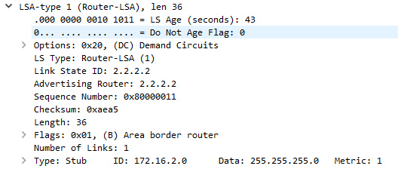



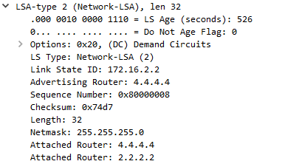



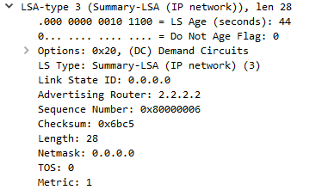



Totally Stubby Area

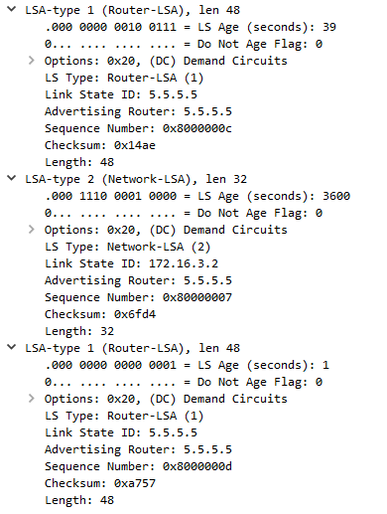



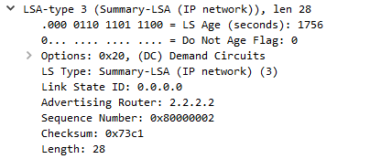



NSSA

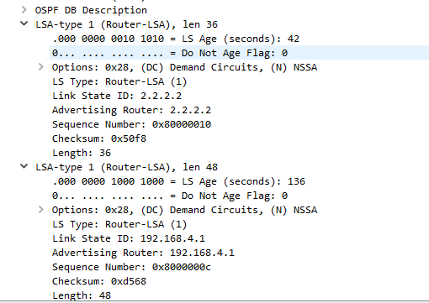



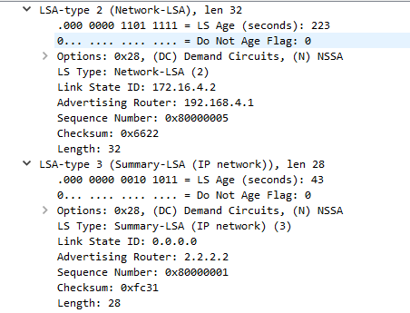



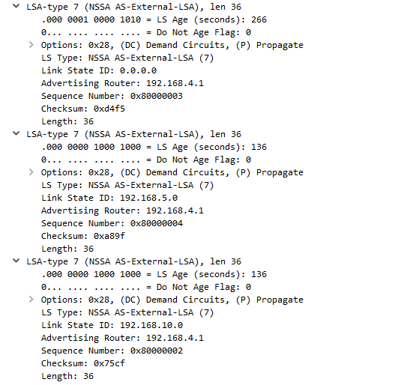



Problems: -

The original topology that we constructed had all routers and required multiple serial connections. We did the configurations on Packet Tracer and when we headed to the racks to copy over the configuration, we learned that we could not have serial connections in our topology because they have a very limited use, every time they are detached from the routers, and so, we replaced all the serial connections in our topology with ethernet cables and make necessary changes to our configuration, and replaced the ABR, which was originally a router, with a layer 3 switch, due to the shortage of usable routers.

After making changes to our configurations and copying them over to all the modes in our topology, we opened Wireshark to capture the OSPF packets required to verify the working of all the areas. We, however, noticed that we were not able to get the LSA packets on Wireshark. After a little research on the internet, we found out that SPAN was needed to be configured on the ABR to get the OSPF LSA captures on the protocol analyzer. We enabled SPAN on our ABR and were able to get the desired result.

Conclusions: -

The purpose of the lab was efficiently carried out, which was to gain an experience on configuring different kinds of OSPF areas, while already knowing about the functioning of the areas. The lab helped us go in depth between the areas used in the lab and how they differ. We had gathered a little knowledge on this topic, thanks to the research that we did, but through this lab, we possess the ability to explain anyone else about this topic effectively. This lab also made us configure SPAN, and hence refreshed our memory on configuring Port Mirroring on a node.